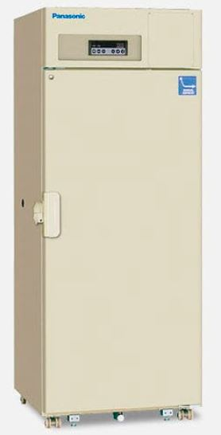
The Children’s Cancer Centre Tissue Bank is collecting an increasing number of samples and storage was reaching capacity. Our new -30°C freezer will allow storage of DNA extracted from patient samples.
The freezer has the capacity to hold DNA from 15,000 samples. There are currently 3,000 samples awaiting DNA extraction. These samples are bone marrow from patients with solid tumours. In future we will also store DNA extracted from solid tumours themselves. We receive approximately 120 solid tumour specimens per year with matched blood and bone marrow.
When stored correctly, DNA extracted from a single patient sample can be used for multiple projects. Tissue samples from cancer patients need to be stored indefinitely. These samples can be retested as new knowledge and new technologies become available.
The freezer will also store reagents that are needed for the cell lines to grow. These includes growth factors and antibiotics. These reagents are used to generate the neurosphere cultures which grow from high grade brain tumours including those obtained post-mortem.
Three interesting projects that are currently being supported as a result of acquiring this freezer:
- DNA was extracted from eight medulloblastoma (malignant brain tumour) specimens. A portion of this DNA was sent to the Hudson Institute of Medical Research in Clayton. Researchers are establishing a new method to test changes to the DNA molecules called methylation which in future will better inform clinical care.
- DNA was extracted from two rare T-cell lymphoma samples which contributed to an international study at McGill University Health Centre in Montreal. To date less than thirty paediatric patients with this tumour type have been reported in the literature worldwide. Our Tissue Bank was able to supply DNA from two patients, contributing significantly to this multi-centric study.
- The freezer is being used to store DNA extracted from plasma. The detection of circulating free DNA from tumour cells in blood is becoming a viable tool in cancer care. This can be used to assist in the diagnosis of tumours, for disease monitoring and as a method for discovery about cancer biology. This research is being conducted at MCRI in collaboration with overseas researchers.
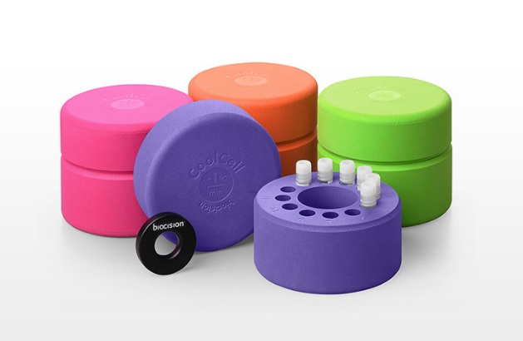

The Murdoch Children’s Research Institute is grateful for this gift, which was given in memory of Fiona Gilchrist (née Love). We are also grateful to CIKA and their supporters for their ongoing dedication to raising vital funds to support the Children’s Cancer Centre Tissue Bank.

